SIMATS ENGINEERING

ASSESSMENT TOOL 1: Constraint-Based Problem Solving

COURSE NAME: | Cloud Computing and  Big Data Analytics | COURSE CODE: | CSA1508

COURSE OUTCOME COVERED
CO5: Design big data processing systems using the Hadoop ecosystem including HDFS, MapReduce, and YARN.
(BL5)

Dave's Taxonomy: Articulation (Level 4)  Question Count: 5 | Total Marks: 50

Code of Conduct
I P.Muni Lokesh (192372181) (Name / Reg. No.) certify that this submission is my original work and that I have adhered to the guidelines specified for this assessment.
I understand that any violation of academic integrity rules will result in disciplinary action. Signature of the student: P.MuniLokesh

Assessment Tasks

Constraint-Based Problem Solving
- Design an HDFS-based storage solution for a media platform under the constraints that data availability must remain above 99.9%, replication factor cannot exceed 3, and storage growth must stay cost efficient. Justify your design.
Answer:
Constraints Identified and Prioritized
- Availability > 99.9%: roughly 8.7 hours of downtime allowed per year, which rules out a single-NameNode design since the NameNode is a single point of failure in classic HDFS.
- Replication factor ≤ 3: durability and read-throughput must be engineered within a maximum of 3 copies per block — this is the tightest constraint, since it caps how much fault tolerance can come from raw replication alone.
- Cost-efficient storage growth: a media platform's storage grows continuously (new uploads) while old content is accessed rarely, so cost efficiency has to come from a growth strategy, not just hardware choice.
These three constraints interact: pushing replication factor to 3 everywhere would maximize durability and availability but directly conflicts with cost efficiency at media-platform scale, since video/image assets are large. The design below resolves this by treating replication and erasure coding as complementary, not competing, tools.

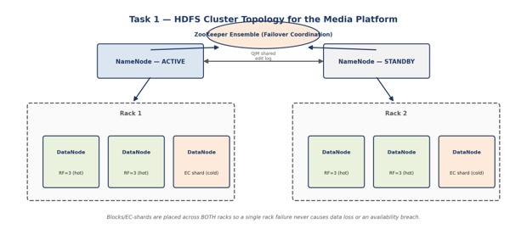
Proposed Design
- NameNode High Availability: deploy HDFS in HA mode with an Active and Standby NameNode, coordinated by ZooKeeper for automatic failover and using the Quorum Journal Manager (QJM) to share edit logs, so a NameNode crash no longer takes the cluster offline — this directly targets the 99.9% availability constraint at the metadata layer, which is the most common single point of failure.
- Tiered replication strategy: recently uploaded and frequently streamed media ("hot" content) is stored at the maximum allowed replication factor of 3, maximizing both read parallelism (popular content is fetched by many users concurrently) and fault tolerance where it matters most.
- Erasure coding for cold/archival media: older, rarely accessed media (older uploads, archived masters) is converted to HDFS Erasure Coding (available since Hadoop 3.x), which achieves similar or better durability than 3x replication at roughly 1.5x storage overhead instead of 3x — this is the key lever that satisfies the cost-efficiency constraint without violating the replication-factor cap, since erasure-coded blocks are not "replicas" in the RF sense at all.
- Rack awareness: DataNodes are organized across multiple racks, and HDFS's rack-aware block placement policy places replicas/EC shards across racks so a single rack failure (power, switch) does not risk data loss or an availability outage.
- Storage lifecycle policy: an automated policy (e.g., using HDFS storage policies or a lifecycle job) migrates content from hot (3x replication, SSD-backed) to cold (erasure-coded, HDD-backed) tiers based on access-frequency thresholds, so cost efficiency improves automatically as content ages rather than requiring manual intervention.
Justification: How Each Constraint Is Satisfied
- Availability: NameNode HA removes the metadata single point of failure; rack-aware placement prevents a single infrastructure failure from taking data offline; combined, these push realistic availability well past 99.9% for a properly operated cluster.
- Replication factor ≤ 3: hot data uses exactly RF = 3 (the constraint ceiling, used only where the durability/performance payoff is highest); cold data sidesteps the constraint entirely by using erasure coding, which is governed by its own parity-shard configuration, not the RF setting.
- Cost efficiency: erasure coding on cold data cuts storage overhead roughly in half compared to 3x replication for the majority of the platform's data (since most media becomes "cold" over time), directly reducing storage cost growth as the platform scales.

- A MapReduce workflow must process log data within a 20-minute batch window using limited cluster nodes. Propose a job design under these constraints and explain task distribution.
Answer:
Constraints Identified and Prioritized
- Hard time budget: the entire job must complete within 20 minutes, which is the dominant constraint — it bounds how much data can be processed per run and forces every design choice to be evaluated against wall-clock time, not just throughput.
- Limited cluster nodes: a small cluster means limited parallelism, so the job design has to extract maximum useful parallel work from few nodes rather than relying on horizontal scale to hide inefficiency.
Because both constraints limit total available compute-time, the job design strategy is to minimize wasted work (shuffle volume, task startup overhead, stragglers) rather than to simply add resources, since resources are capped.
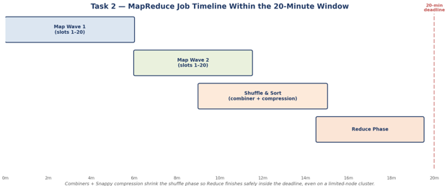
Proposed Job Design
- Input split sizing: set the HDFS block size / split size so that the number of map tasks is a small multiple of the total available map slots (e.g., 2-3x), avoiding both very large splits (which create long-running straggler mappers that blow the time budget) and very small splits (which waste time on JVM/container startup overhead across many nodes).
- Combiner functions: apply a combiner wherever the reduce operation is associative and commutative (e.g., counting log event types), performing local pre-aggregation on each mapper's output before shuffle — this is the single highest-leverage optimization under a tight time budget because it directly cuts the volume of data transferred across the network during shuffle, which is often the slowest phase of a MapReduce job.
- Compression: enable intermediate (map-output) compression (e.g., Snappy, chosen for its low CPU overhead and fast decompression versus higher-ratio but slower codecs like Gzip) to further shrink shuffle traffic without adding meaningful CPU-bound latency.
- Reducer count tuning: size the number of reducers to match available reduce slots on the limited node count, avoiding an excessive number of small reducer tasks (task-scheduling overhead dominates) or too few large ones (creates a bottleneck / long tail at the end of the job).
- Speculative execution: enable speculative execution for straggler mitigation so that if one node runs unusually slow (hardware issue, resource contention), a duplicate task is launched elsewhere and the faster result is used — important insurance against the 20-minute deadline being missed due to a single slow node.
Task Distribution Explanation
With a limited node count, task distribution follows a wave-based model: if the cluster supports, for example, 20 concurrent map slots and the job is split into 40 map tasks, the job runs in two waves of roughly equal size. The design goal is to make each wave's tasks as evenly sized as possible (via consistent split sizing) so no wave is bottlenecked by one oversized task — an uneven split is the most common reason a MapReduce job blows a tight time budget on a small cluster, since the whole job waits on the slowest task in the final wave.
Justification
- Meeting the 20-minute window: combiners and compression reduce shuffle time (often the largest controllable cost), while split sizing and speculative execution reduce the risk of any single task extending the critical path — together these target the job's actual bottlenecks rather than just adding raw resources that the constraint does not allow.
- Working within limited nodes: sizing map/reduce task counts to match actual slot availability (rather than over-provisioning tasks) minimizes scheduling and context-switch overhead, extracting the most useful work from the fixed, small resource pool available.

- A YARN-managed cluster supports ETL, reporting, and machine learning jobs. Design a scheduler policy under the constraints of fairness, priority for ETL, and recovery from node failure
Answer:
Constraints Identified and Prioritized
- Fairness: reporting and ML jobs must not be starved of resources indefinitely — some baseline share of the cluster must remain available to them even during busy periods.
- ETL priority: ETL jobs (which typically feed both reporting and ML with fresh data) must get resources first / faster than the other two workload types, since delayed ETL delays everything downstream of it.
- Recovery from node failure: the scheduler and cluster as a whole must continue operating and re-assign work correctly when a node fails mid-job, without manual intervention.
Fairness and ETL priority are in mild tension — pure fairness would give all three workloads equal claim to resources, while a strict priority queue for ETL could starve reporting/ML entirely during heavy ETL load. The design below resolves this using YARN's Fair Scheduler with weighted, guaranteed minimum shares per queue, which supports both properties simultaneously rather than forcing a choice between them.
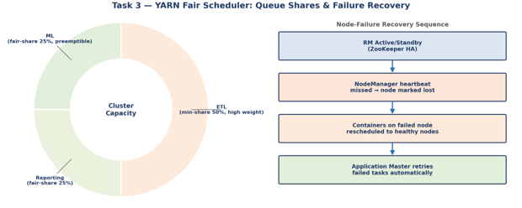
Proposed Scheduler Policy
- Scheduler choice: YARN Fair Scheduler (over Capacity Scheduler) is selected because it natively supports guaranteed minimum resource shares per queue while still fairly redistributing spare capacity across active queues — a good fit for a workload mix where ETL needs guaranteed headroom but reporting/ML should still be able to use idle capacity.
- Queue structure: three queues are configured — etl, reporting, and ml — each mapped to its respective job type via YARN queue placement rules.
- ETL priority via minimum share + weight: the etl queue is configured with a guaranteed minimum resource share (e.g., 50% of cluster capacity) and a higher scheduling weight, so ETL jobs are allocated resources first when the cluster is under contention, satisfying the priority requirement without completely locking out other queues.
- Fairness for reporting and ML: the remaining capacity is fair-shared between the reporting and ml queues (equal weights by default, adjustable if one workload is judged more business-critical), and each queue is allowed to borrow idle capacity from other queues when the cluster is underutilized, maximizing overall cluster efficiency.
- Preemption: preemption is enabled so that if the ml or reporting queue temporarily exceeds its fair share while etl is idle, and etl then submits new jobs, YARN can reclaim containers from the over-allocated queue rather than making ETL wait — this is what makes the priority guarantee actually enforceable rather than just aspirational.
- Node failure recovery: ResourceManager High Availability (Active/Standby RM coordinated via ZooKeeper) ensures the scheduler itself survives a master-node failure; at the worker level, NodeManager heartbeats let the ResourceManager detect a failed node within a configurable timeout and automatically reschedule its containers/tasks onto healthy nodes, with YARN's application master retry logic re-launching failed tasks so jobs recover without manual restart.
Justification
- Fairness: the fair-share pool for reporting and ML, combined with idle-capacity borrowing, guarantees neither workload is permanently starved, satisfying the fairness constraint even under contention.
- ETL priority: the guaranteed minimum share plus preemption gives ETL a durable, enforceable priority rather than a soft preference that can be ignored under load.
- Failure recovery: RM HA removes the scheduler itself as a single point of failure, while NodeManager heartbeat-based failure detection and automatic container rescheduling ensure worker-node failures are absorbed transparently, meeting the recovery constraint without manual operator intervention.

- An enterprise needs to ingest data from SAN, NAS, and operational databases into a big data platform while maintaining backup reliability and minimal duplication. Propose a constrained architecture and justify each component.
Answer:
Constraints Identified and Prioritized
- Multiple heterogeneous sources: SAN (block storage), NAS (file storage), and operational databases (OLTP) each require a different ingestion mechanism — no single tool natively handles all three well.
- Backup reliability: ingested data must be recoverable even if the ingestion pipeline, source system, or target cluster experiences failure — this is a hard requirement, not a nice-to-have.
- Minimal duplication: the design must avoid re-ingesting unchanged data (wasting storage and cluster I/O) and avoid duplicate records landing in the big data platform, which would corrupt downstream analytics.
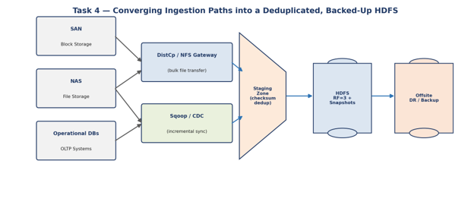
Proposed Architecture
- SAN/NAS ingestion: for SAN, data is exposed and transferred using block-to-file gateways or by mounting SAN volumes to a staging server and bulk-copying with DistCp for cluster-parallel transfer; for NAS, HDFS's NFS Gateway or DistCp directly reads shared file exports, since NAS is already file-oriented and integrates naturally with Hadoop's file-based ingestion tools.
- Operational database ingestion: Apache Sqoop (or a CDC — Change Data Capture — tool such as Debezium for continuous sync) extracts data from operational databases; CDC is specifically preferred over full-table Sqoop dumps wherever the source supports it, because CDC ingests only changed rows, which is the primary lever for satisfying the minimal-duplication constraint on the database side.
- Staging zone with checksum deduplication: all ingested data lands first in a staging area where checksums (e.g., MD5/SHA hashes per file or record batch) are computed and compared against previously ingested checksums before promotion to the permanent HDFS location, catching accidental re-ingestion (e.g., a retried failed job re-sending the same batch) before it duplicates data downstream.
- HDFS storage with snapshots: ingested data is stored in HDFS at replication factor 3, with HDFS Snapshots taken on a defined schedule (e.g., daily) — snapshots are near-instantaneous and space-efficient (only storing deltas), giving a fast recovery point without doubling storage cost the way full periodic copies would.
- Offsite backup / DR: beyond in-cluster replication and snapshots, a scheduled DistCp job replicates critical datasets to a geographically separate DR cluster or cloud cold-storage target, ensuring backup reliability survives a full site-level failure, not just a node-level one.
- Orchestration: the end-to-end flow (extract → stage → deduplicate → load → snapshot → replicate) is coordinated by a workflow orchestrator (Apache Oozie or Apache Airflow) so ingestion runs on a reliable, auditable schedule with automatic retry/alerting on failure rather than depending on manual triggering.
Justification: How Each Constraint Is Satisfied
- Heterogeneous sources: each source type is matched to the ingestion tool best suited to its native access pattern (block/file transfer for SAN/NAS, CDC/Sqoop for databases) rather than forcing one tool to awkwardly handle all three, which keeps each ingestion path reliable and maintainable.
- Backup reliability: the design layers three independent safety nets — in-cluster replication, space-efficient snapshots, and offsite DR replication — so no single failure mode (disk failure, accidental delete, site outage) results in permanent data loss.
- Minimal duplication: CDC-based database ingestion and checksum-based staging deduplication together address duplication at both the source-extraction level and the load level, which is more robust than relying on either technique alone.

- Design an end-to-end Hadoop ecosystem solution under the constraints of secure data movement, high availability, and integration with Apache NiFi or ETL pipelines. Explain how your design satisfies all constraints.

Answer:

Constraints Identified and Prioritized
- Secure data movement: data must be protected both in transit (between sources, NiFi, and the cluster) and at rest, with strong authentication of who/what is moving data.
- High availability: no single component failure (NameNode, ResourceManager, NiFi node) should cause a platform-wide outage.
- Integration with Apache NiFi / ETL pipelines: the design must cleanly incorporate NiFi (or an equivalent ETL pipeline) as the ingestion/orchestration layer feeding the Hadoop ecosystem, not bolt it on separately.

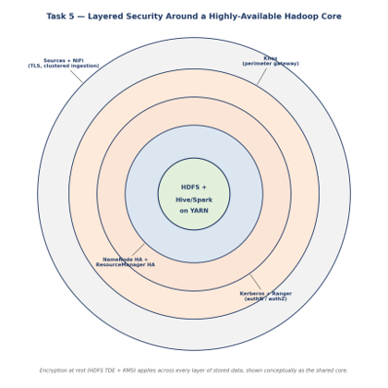

Proposed End-to-End Design
- Secure ingestion via NiFi: Apache NiFi acts as the ingestion and flow-management layer, connecting to source systems over TLS-encrypted channels; NiFi's built-in data provenance tracking also gives an auditable record of exactly how each piece of data moved through the pipeline, which supports both security auditing and troubleshooting.
- Authentication and authorization: the cluster is secured with Kerberos for strong authentication of every user, service, and NiFi processor interacting with Hadoop, ensuring only verified identities can read or write data; Apache Ranger (or Apache Sentry) then layers fine-grained, centrally managed authorization policies on top — for example, restricting which teams can access which Hive tables or HDFS directories.
- Perimeter security: Apache Knox provides a single, hardened REST API gateway for external access into the cluster, so individual services (NameNode UI, YARN UI, Hive) are not directly exposed to the network — this reduces the attack surface, which matters because "secure data movement" includes securing the entry points, not just the data itself.
- Encryption at rest: HDFS Transparent Data Encryption (TDE) encrypts sensitive data zones on disk using per-zone encryption keys managed by a Key Management Server (KMS), so data remains protected even if physical storage media is compromised.
- HDFS High Availability: NameNode HA (Active/Standby, coordinated via ZooKeeper and QJM for shared edit logs) removes the metadata layer as a single point of failure, as in Task 1.
- YARN High Availability: ResourceManager HA (Active/Standby via ZooKeeper) ensures job scheduling and resource management continue uninterrupted through a master-node failure, as in Task 3.
- NiFi clustering: NiFi itself is deployed in cluster mode (multiple NiFi nodes coordinated via ZooKeeper) rather than as a single instance, so an individual NiFi node failure does not halt data ingestion — flows are automatically redistributed across the remaining nodes.
- Processing and integration: downstream of ingestion, Hive and Spark run as YARN-managed applications for ETL transformation, ad-hoc querying, and machine learning, with NiFi able to trigger and monitor these jobs as part of its flow (e.g., via NiFi's Hadoop/Hive processors), giving a single coordinated pipeline from raw ingestion through to analytics-ready data.
How the Design Satisfies All Constraints
- Secure data movement: TLS in transit, Kerberos authentication, Ranger authorization, Knox perimeter gating, and HDFS TDE at rest together secure data at every stage of its journey — from source, through NiFi, into the cluster, and at final storage — rather than securing only one hop in the pipeline.
- High availability: every stateful control-plane component with a single-instance failure risk (NameNode, ResourceManager, NiFi) is deployed redundantly, so the platform has no single point of failure across ingestion, storage, or processing layers.
- NiFi/ETL integration: NiFi is positioned as the entry point and orchestration layer feeding Hadoop-native processing (Hive/Spark on YARN), giving a coherent pipeline rather than a disconnected ingestion tool sitting outside the ecosystem — this satisfies the integration requirement while also reinforcing the security and availability goals, since NiFi's clustering and provenance features directly support both.

Constraint-Based Problem Solving Rubric

Criteria | Weightage | Level 4 - Exemplary | Level 3 - Proficient | Level 2 - Developing | Level 1 - Beginning | Total Marks
Understanding of Constraints | 25% | All technical constraints are identified and prioritized  accurately | Most constraints identified | Some constraints identified | Constraints poorly understood
System Design Quality | 25% | Design is robust, feasible, and aligned to  constraints | Reasonable design | Basic design with gaps | Weak design
Application of Hadoop Concepts | 20% | Uses HDFS, MapReduce, YARN, and integration  concepts effectively | Mostly effective use | Partial use of concepts | Weak concept application
Justification | 15% | Strong technical  reasoning for all choices | Good justification | Basic justification | Little justification
Clarity | 15% | Clear, well-structured, and  professional answer | Mostly clear | Somewhat unclear | Poorly structured

